Copyright (c) 2023 Hovl Studio (Vladyslav Horobets)
When you purchase this asset, you get a license to use effects, models, textures, scripts, shaders and materials based on the Unity Asset Store license.
License does NOT apply to contents of "Demo scene" folder! It’s also mean that asset support doesn’t apply to animations and scripts that are used in the demo scene, but you can use scripts under the Asset Store license.
Asset includes:
30 prefabs (10 complete projectiles with hit and flash effects)
“HQ PBR Fantasy staff” asset as addition https://assetstore.unity.com/packages/slug/121251
Using
1. Scripts
1) HS_TargetProjectile. Used for moving object to the target. Automatically deleted when no target. The target is set using another script. Example:
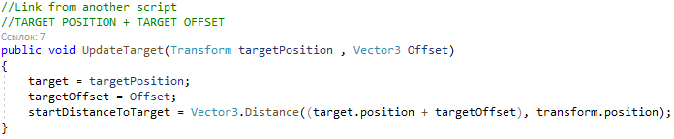
The speed, hit and flash effect (can be null) can be set in this script.

2. Light
When using light sources in effects with HDRP, problems may arise on the stage. If you find a bug, you need to remove the light source from effect prefab.
3. Shaders
3.1) The "Use depth" on the material from the custom shaders is the Soft Particle Factor.
3.2) Use "Center glow"[MaterialToggle] only with particle system. This option is used to darken the main texture with a white texture (white is visible, black is invisible). If you turn on this feature, you need to use "Custom vertex stream" (Uv0.Custom.xy) in tab "Render". And don't forget to use "Custom data" parameters in your PS.
3.3) The distortion shader only works with standard rendering. Delete (if exist) distortion particles from effects if you use LWRP or HDRP!
3.4) You can change the cutoff in Blend_TwoSides shader using (Uv0.Custom.xy) in particle system.
3.5) The ShockWave shader. "Custom vertex stream" (Uv0.Custom.xy) is responsible for tiling.
"Custom vertex stream" (Uv2.Custom.xy) is responsible for opacity and glow amount from black.
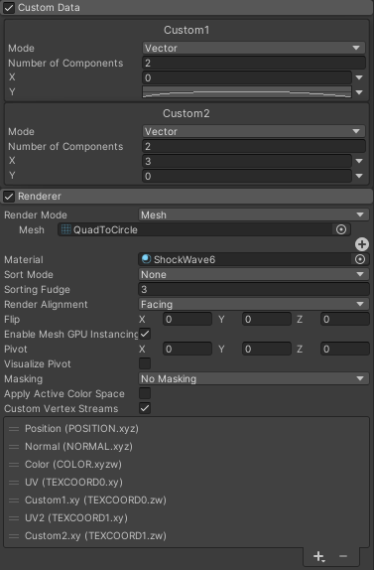
4. Universal Render Pipeline (URP) and High Definition Render Pipeline (HDRP)
Works only from Unity 2019.2+!
Enable Depth and Opaque Textures in URP settings! -----------
SUPPORT ASSET FOR URP(LWRP) or HDRP here --> https://assetstore.unity.com/packages/slug/157764
SUPPORT ASSET FOR URP(LWRP) or HDRP here --> https://assetstore.unity.com/packages/slug/157764
SUPPORT ASSET FOR URP(LWRP) or HDRP here --> https://assetstore.unity.com/packages/slug/157764
6. Post Processing
If you want to use post-effects like in the demo video:
https://youtu.be/hZSZ2Q8MF3k
7. Quality
For better sparks quality enable "Anisotropic textures: Forced On" in quality settings.
Support email
gorobecn2@gmail.com

